**Data Structures and Algorithms**

**Lab Report**

**Lab07**



|  |  |
| --- | --- |
| Group Members Name & Reg #: | **Muhammad Haris Irfan**  **(FA18-BCE-090)** |
|  |  |
| Class | Data Structures and Algorithms CSC211 (**BCE-3B**) |
| Instructor’s Name | Dilshad Sabir |

**In Lab Tasks**

**Task:1**

**Convert the following iterative function to a recursive one.**

**Solution:**

The code is shown below,

Code:

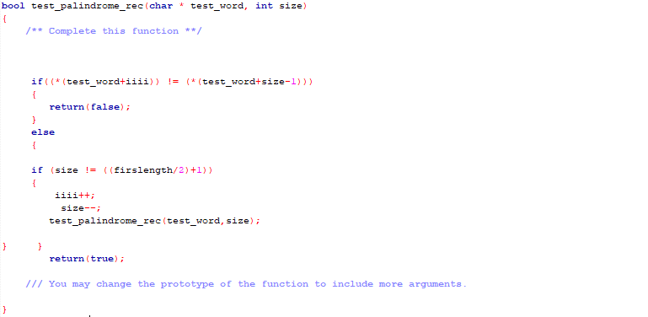

The Result of the following code is attached below:

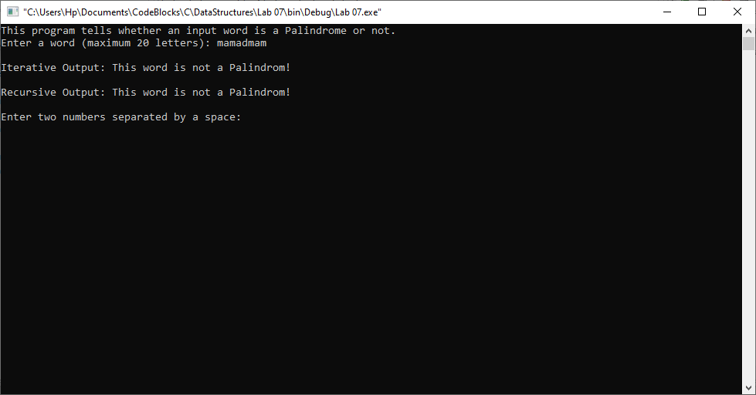

-------------------------------

**Task:2**

**Convert the following recursive function to iterative one.**



**Solution:**

The code is shown below,

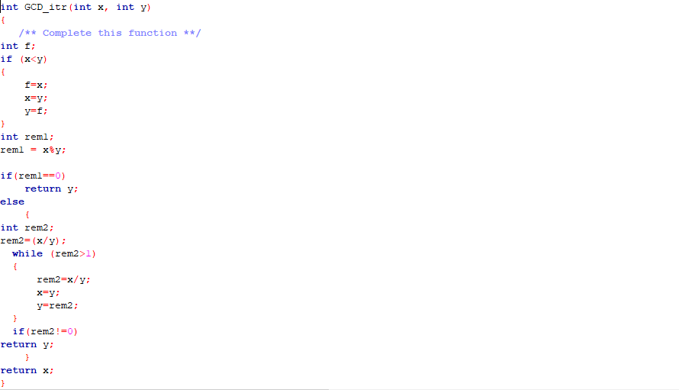

The Result of the following code is attached below:

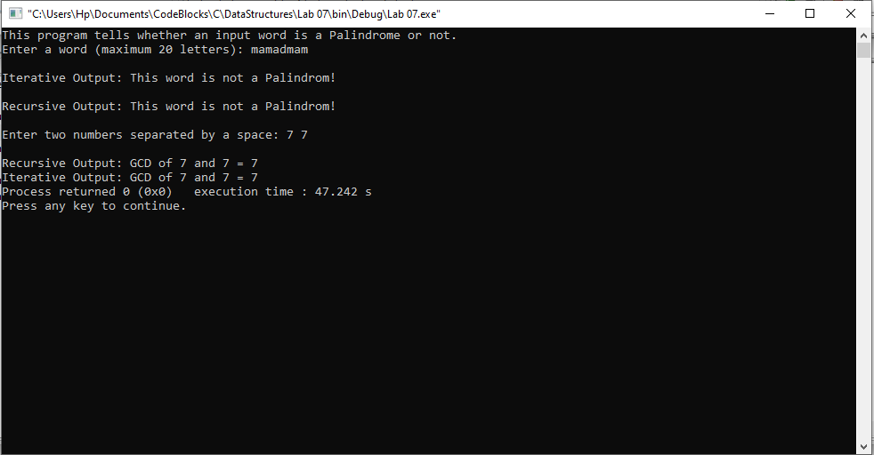

-------------------------------

**Post Lab Task.**

**Task 3:**

**Write a program to reverse a string using recursion.**

Solution

The code is shown below,

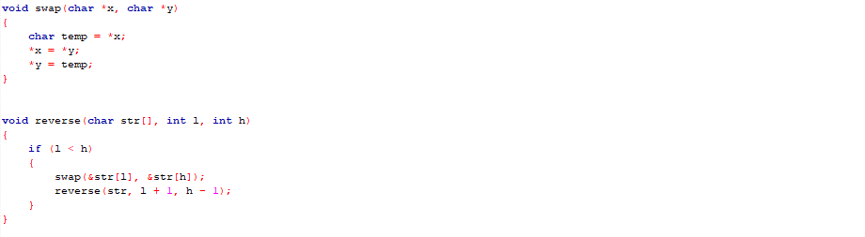

The Result of the following code is attached below:

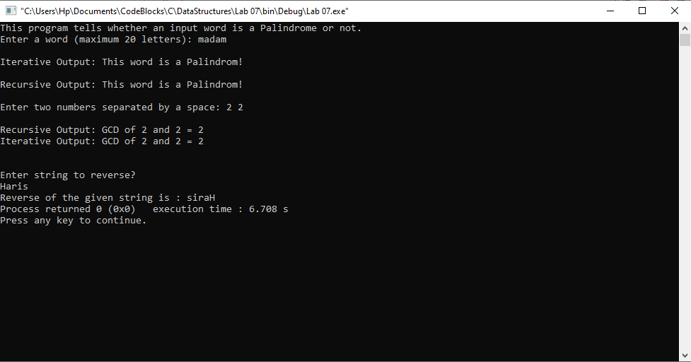

------------------------------

THE END